**CAR TALK (SELL YOUR CAR IN A DAY)**

**Introduction:**

Car talk is an application for selling and buying cars. It is a centralized way of selling and buying cars online without middle man’s help. The app helps users to see cars nearby his area or choose area of interest.



**Flow of application**

1. Application starts by taking the location of the user; if location is on and current location is taken login page is opened. If location is not on app will ask user to enable location.
2. In the login page user can login or he can skip. Unless user is logged in they cannot buy or sell cars, they will be able to view sellers or buyers.
3. After they login, in the maps red dots will be showed, the red dots indicate nearby (depends on the location) sellers/buyers who are registered in the application.
4. When red dot is pressed, he will able to view images of the car.
5. Unless the user is registered to the application, user cannot view details of the application.

**Flow of Project in terms of screen:**

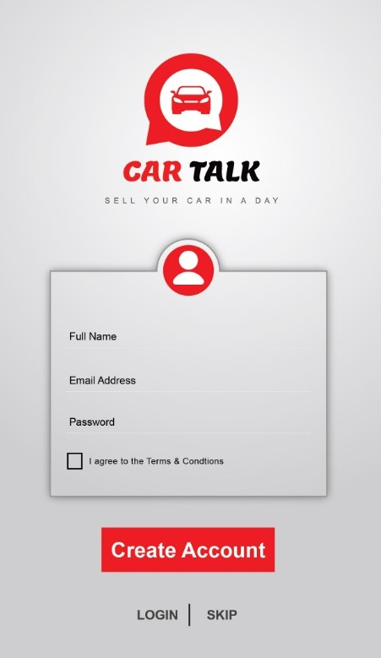

User can skip the login process and directly go to maps page.

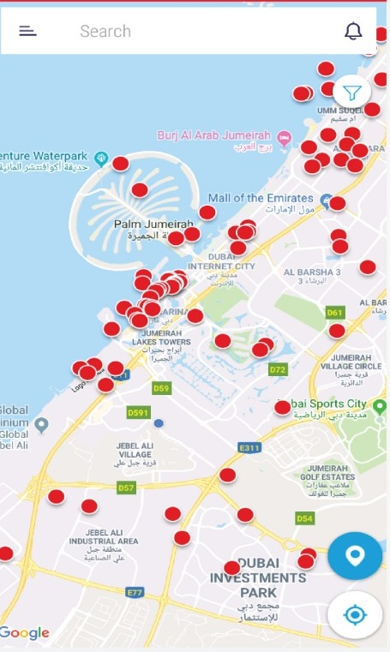

Red dots are the sellers available in the current location of user

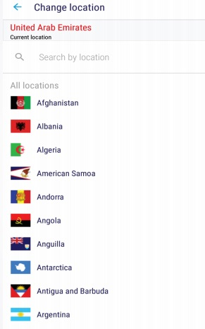

Can view other locations also

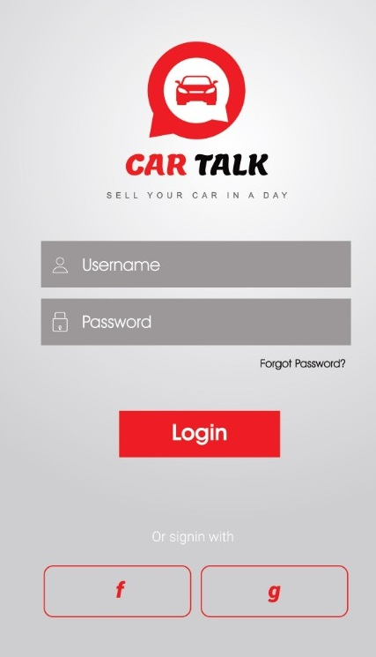

Register to view car details

**Modules:**

1. Admin
2. Seller
3. Buyer

**Seller Module**:

* Register to application by providing all the necessary details.
* Login to application.
* Add all the details of the car (Paper works, Emission Report, Insurance, etc.).
* Can upload 4 images of the car (Front, Left, Right, and Back).
* Request admin for visiting review on the car with a fixed amount charged by the admin.
* After the review a you tube link will be provided by the admin about the car.